## X-Ray Fluorescence

### Theoretical background

The X-ray fluorescence (XRF) method for qualitative and quantitative elemental assay is well known and widely used. It is based on giving the electrons in the inner layers of an atom extra energy to leave the atom. The resulting vacancy is filled with an electron from a higher energy level, which then emits the remaining energy as a photon. Because the energy levels of atoms are discrete and specific to each chemical element, the radiated photons also have discrete energy values. This allows the energy spectrum of fluorescent radiation to be used to detect chemical elements.

An atomic energy level diagram is often used to illustrate X-ray fluorescence. Electron movements between states when they are excited are shown on Figure 1.

Figure 1 - Jablonski diagram for excitation

Purple described absorbed photon which gives electron energy and thus it moves to higher energy level. Green describes internal conversion and vibrational relaxation. Red is fluorescence process when electron is moving towards lower energy levels and thus photon is emitted that can be detected.

High energy particles such as photons, electrons, etc. can be used to provide additional energy to the electrons in the inner layer of atoms. X-ray fluorescence radiation also occurs in the electron capture process by the atomic nucleus. The electromagnetic radiation used for excitation may come from an X-ray tube or a radioactive source. We chose a radioactive source (Am241, radiated photons with an energy of 60 keV) to generate excitation radiation. This makes it possible to identify the elements in the periodic table from 30 to 66. [32] Various methods can be used to measure the fluorescence spectrum, such as using a diffraction grating to separate the spectrum or using a semiconductor detector to measure the energy of the photons. Our experiment uses a thermoelectrically cooled CdTe diode detector. The resolution of the detector must be as high as possible to obtain a good spectrum. The FWHM (full with at half maximum) of the Amtek XR-100T-CdTe detector we use is between 530 and 850 eV depending on the peak energy.

### Laboratory instrumentation

Equipment used: Amtek XR-100T-CdT X-Ray and gamma ray detector with power supply and amplifier, MCA converter to be accessed over USB (designed and built by Veljo Sinivee), sample materials, rotating panel to choose sample material, stepper motor to rotate panel, L298N motor driver to control motor, Arduino development board to give commands over USB and camera to monitor results.

A multichannel analyzer (MCA) is an instrument used in laboratory and field applications, so to analyze an input signal consisting of pulses. MCAs are used extensively in digitizing various spectroscopy experiments, especially those related to nuclear physics, including various types of spectroscopies (alpha-, beta-, and gamma spectroscopy).

Simplified diagram of laboratory structure is described on Figure 2.

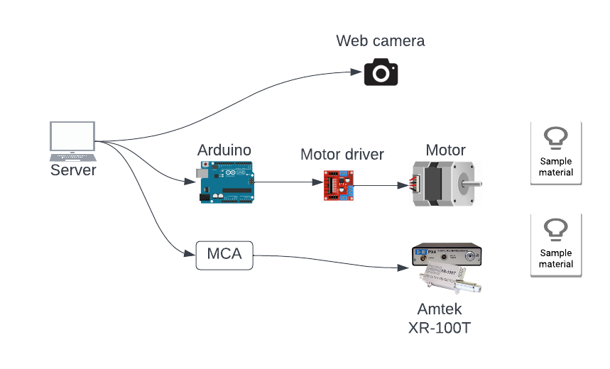

Figure 2 - Hardware components for fluorescence laboratory

Figure 3 describes how stepper motor, LN298 driver, Arduino and power supply are connected to control choosing sample material.

Figure 3 – Arduino, stepper motor, LN298N driver and power supply connections

### How to use laboratory

Steps to use laboratory:

* Start fluorescence lab
* Rotate motor to choose sample material.
* Click ‘Start measurement’, so fluorescence detector starts collecting sample material data and plotting results.
* Collecting results may take up to 24h to get meaningful results. Website can be closed, and user can come back later to collect data.
* Save measurement results and leave fluorescence lab.
* Plot results, find peaks and determine type of sample material.